Write a program in Java to take an array and reverse all the elements of array

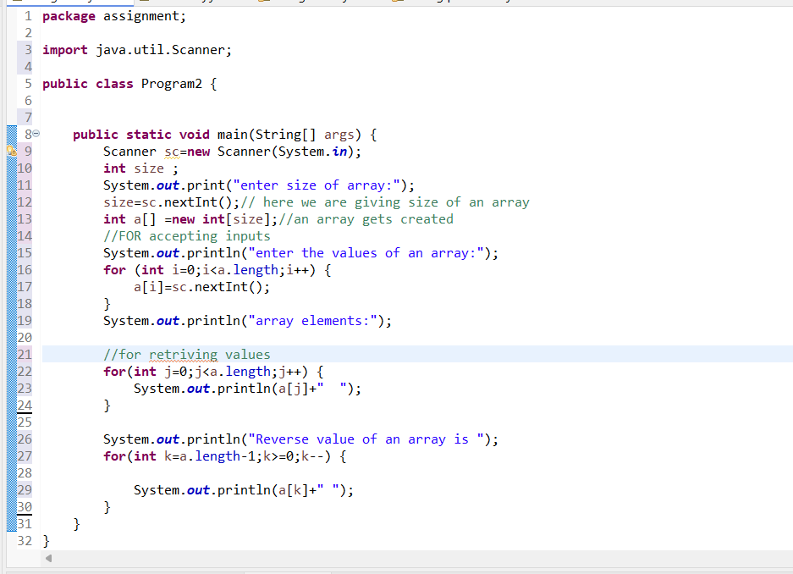

Output:

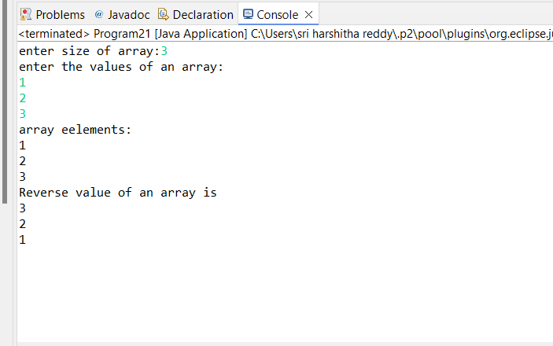

Write a program in Java to find the Sum of all even elements in array

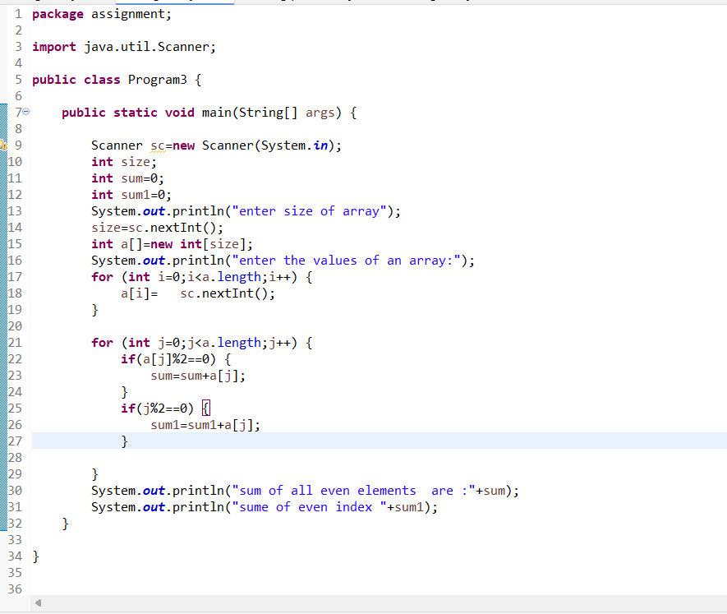

Output:

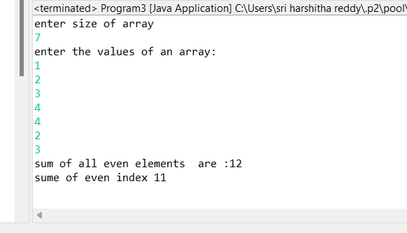

Write a program in Java to remove duplicate elements from array

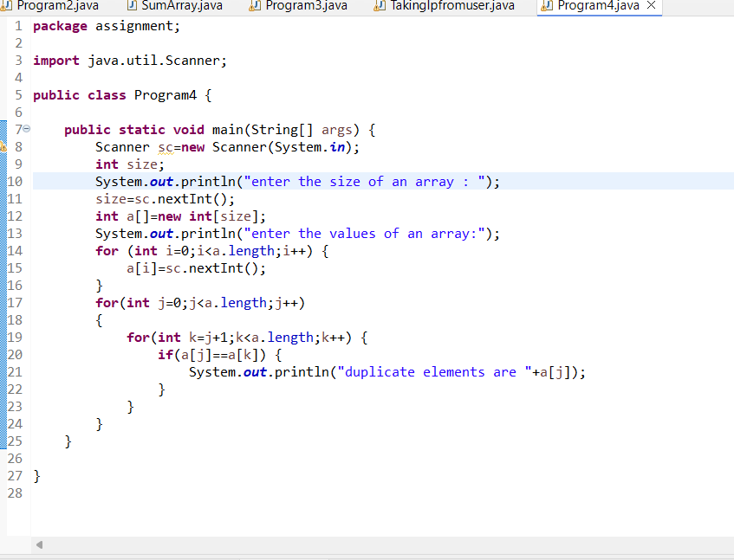

Output:

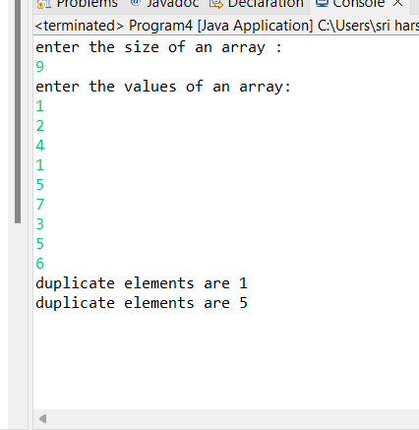

Write a program in Java to find product of two 3\*3 matrix

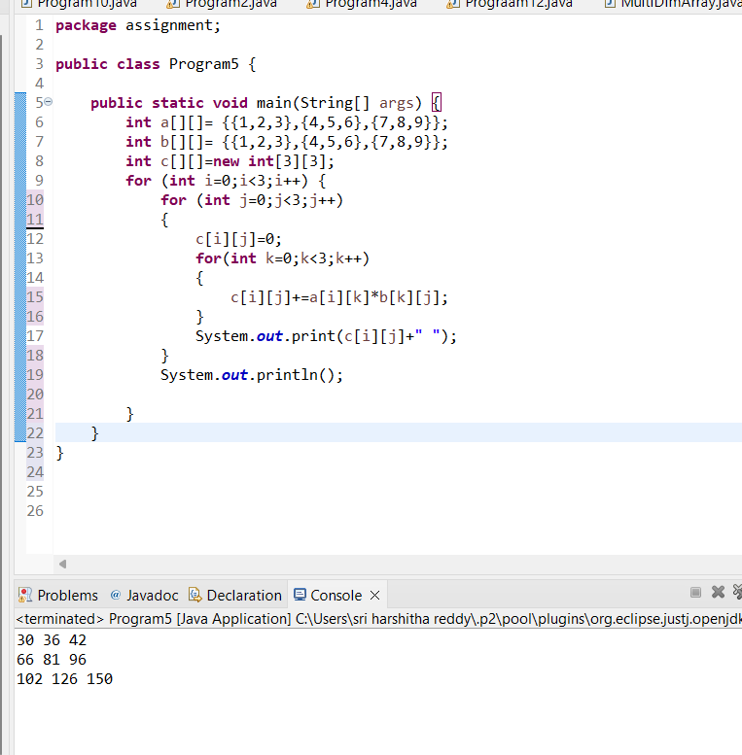

Write a program in java To find the total number of vowels and consonant in string

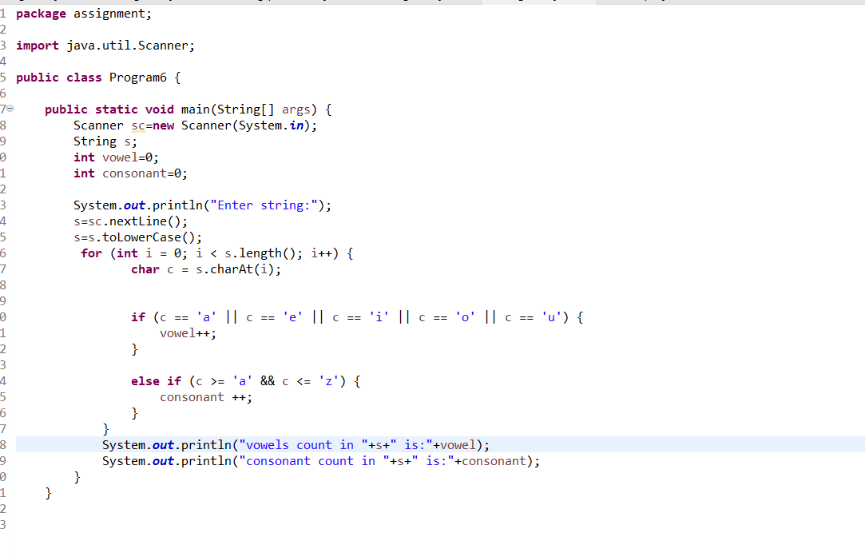

Output:

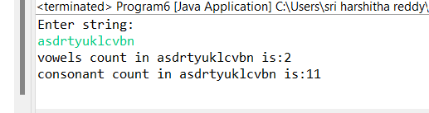

Write a program in java to find the sum of all integer elements from string

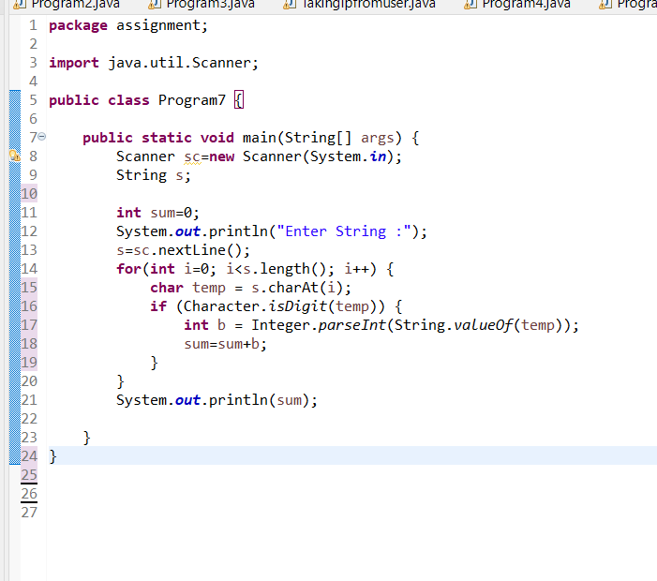

Output:

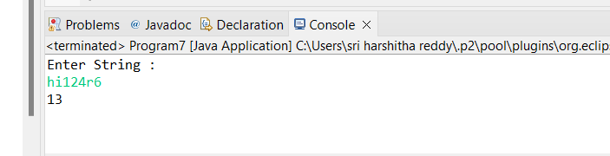

Write a program in java To find the duplicate words from a string

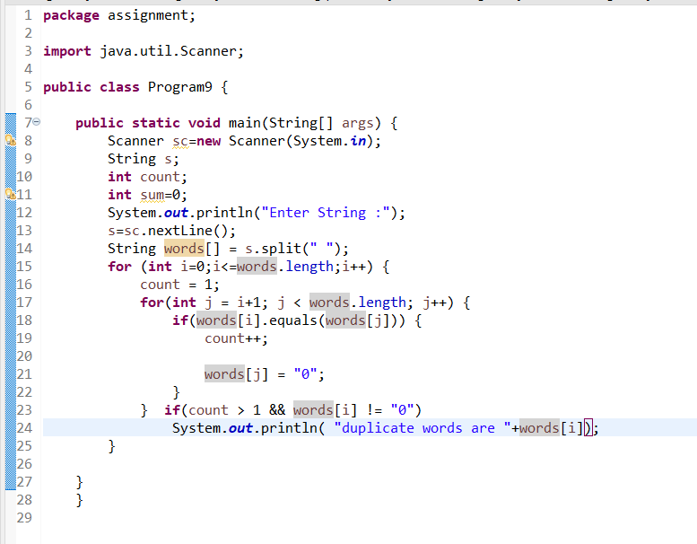

Output

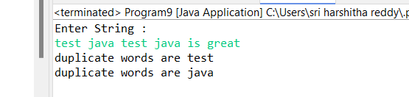

Write a program in java Reverse a string word by word

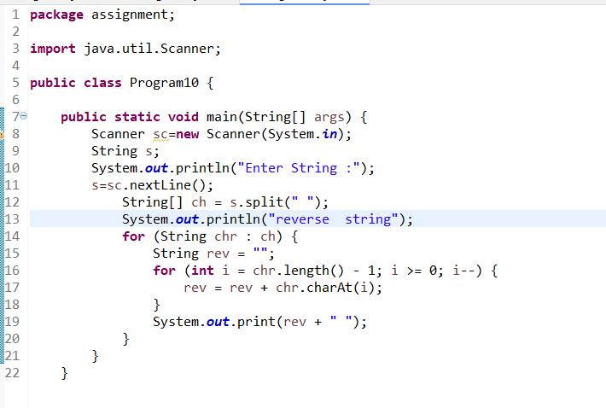

Output:  
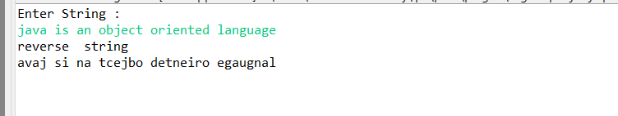

abcDEF@1234cfghi

Write a program in java To Remove all white spaces

Then convert this to upper case

then split the string on basis of @

check in this string a is present or not if present find the index of a

then convert this string to lowercase and reverse this string(without using direct method)

and then check whether palindrome or not

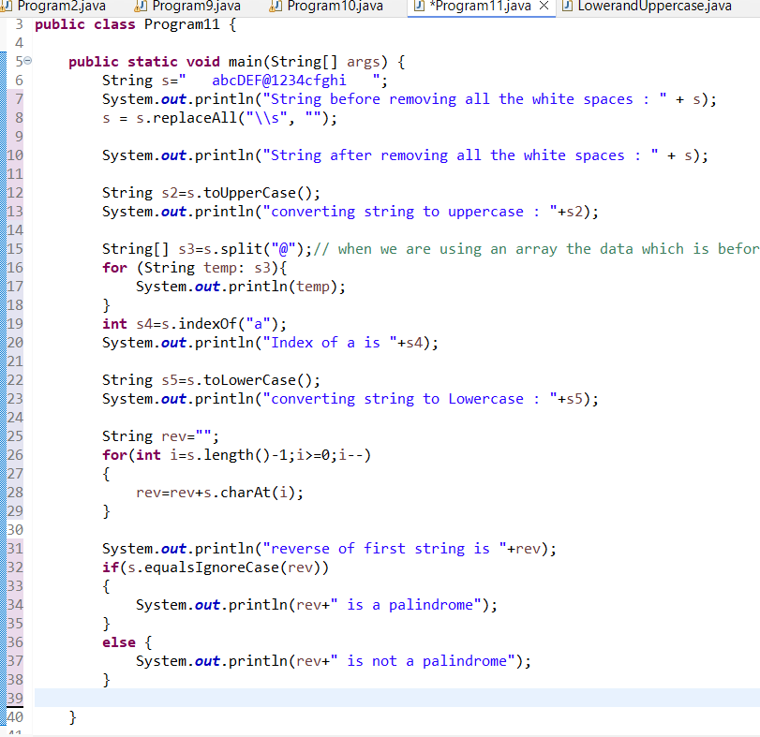

Output:

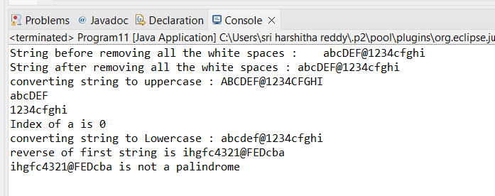

Write a program in java to find the element that appears only once in an array

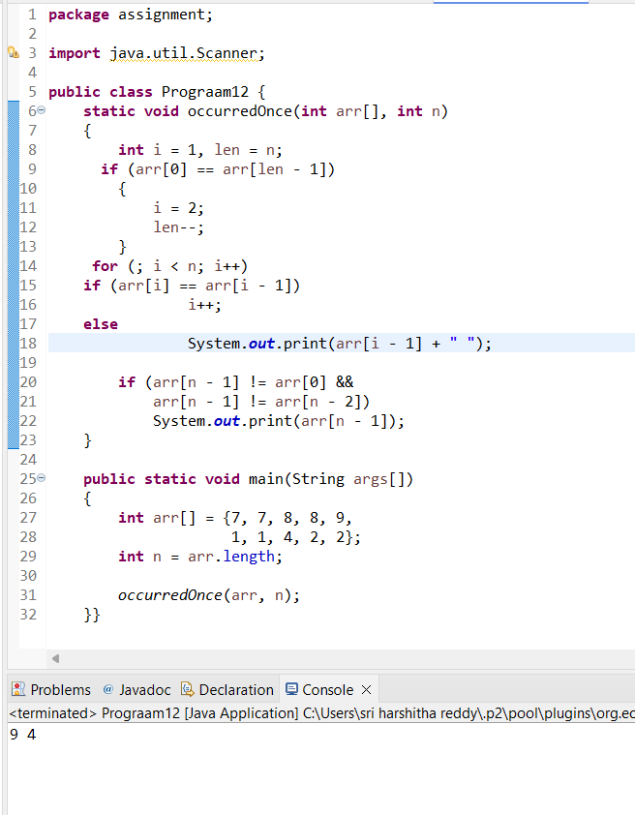

Write a program in Java to check whether two strings are panagram

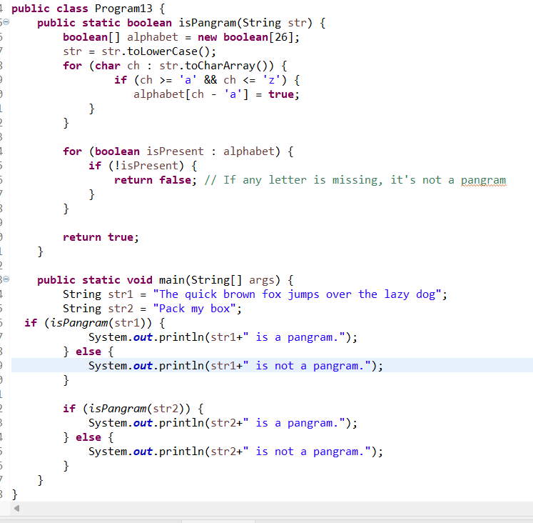

Output:

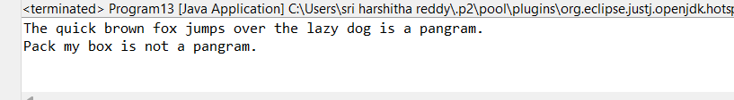

Write a program in Java

Create a Class named Shape with length as instance variable , create three methods as square , rectangle , circle

and find out their respective areas

Create a object in main method and call these different methods with the instance of object

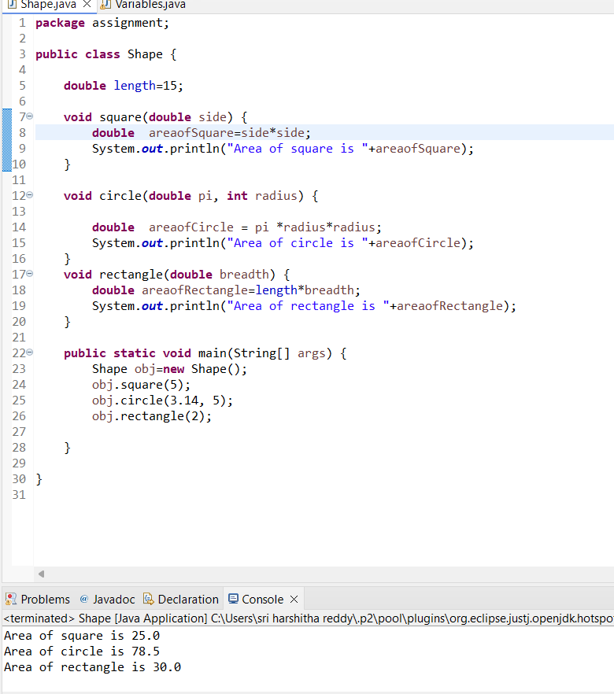

Create a class named school ,create name as their instance variables

Create a default constructor of this class which will have a print statement to display the name of school

Create a method inside the class which will display a message as "This School is based out of Kolkata"

Create a object under main method and call the constructor and the method

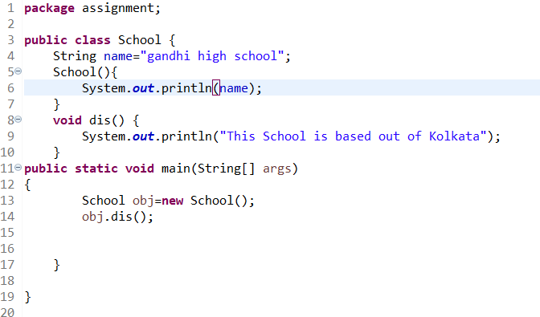

Output:  
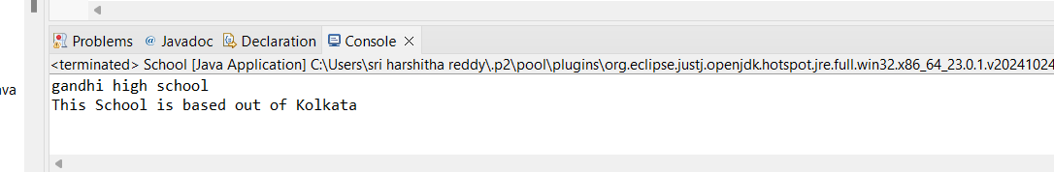

create a class named school

create name, address,strength as their instance variables

Create two constructor one with two variables and one with all the three variables

Create a method that will display all the three parameters

create two object of this class and call the respective methods

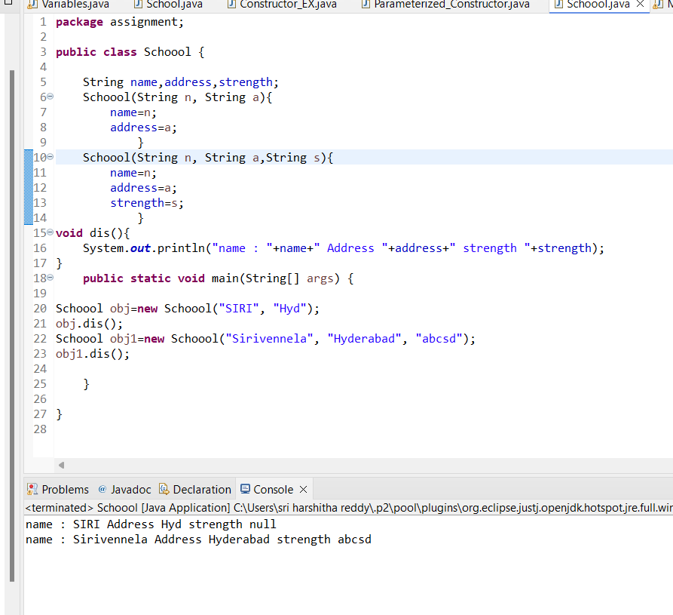

Write a program in Java to take input as array and right rotate the elements 3 times

